About the dongle

1.  Plug the dongle in computer before power on the PC. When ElecRoc 5 is running, do not unplug the dongle from computer.

2. If the dongle was expired, please check the dongle information from ElecRoc server\Help, as following, to see the Expiry Date, then send the information to your local supporter.

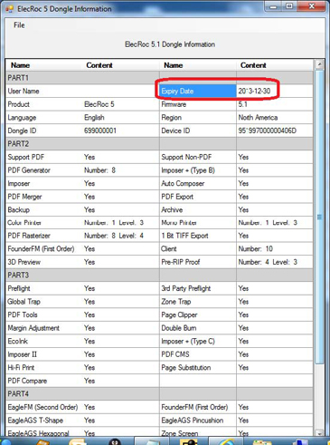

3. If the error appears as following when you run ElecRoc server, the error is Dongle missing or at least one module installed is not enabled on the dongle! Please check if you have installed additional module which is not included in the dongle. Maybe these modules are PDF Generator, Color Printer, Mono Printer, PDF Rasterizer, Pre-RIP Proof, or Post-RIP Proof, etc. When you check the modules which list on the server UI, please compare with the number # that is on the dongle information from Founder ElecRoc 5 Server\Help\ElecRoc 5 Dongle Information.

